HMMSTR：A Hidden Markov Model for Local Sequence-Structure Correlations in Proteins
Christopher Bystroff, Vesteinn Thorsson and David Baker
Journal of Molecular Biology, Vol. 301, pp. 173-190, 2000
Abstract
We describe a hidden Markov model, HMMSTR, for general protein sequence based on the I-sites library of sequence-structure motifs. HMMSTR has a highly branch topology and captures recurrent local features of protein sequences and structures that transcend protein family boundaries.
- Introduction
The I-sites (invariant or initiation sites) library consists of an extensive set of short sequence motifs, lengths 3 to 19 morifs obtained by exhaustive clustering of sequence segments form a non-redundant database of known structures. Each sequence pattern correlates strongly with a recurrent local structural motif in proteins.
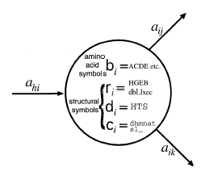
- Description
The model we use here is produced by clustering the I-sites motifs based on hierarchical pairwise alignments, followed by training on sequence plus backbone angle data.

One approach to initializing the HMM topology employed pairwise all-against-all dynamic programming alignment of the 262 I-sites motifs using the correlation between the amino acid frequency profiles as the similarity measure. To force aligned positions to have the same backbone conformation, a large negative value was added to the pairwise score if there was a backbone angle deviation of more than 90º between aligned positions.

Created by : Rei-Sing Cheng
Date : Nov. 15, 2002

